Project Design Phase-II
Data Flow Diagram & User Stories

Date | 31 January 2025
Team ID | PNT2022TMID45799
Project Name | TrafficTelligence: Advanced Traffic Volume Estimation with Machine Learning
Maximum Marks | 4 Marks

Data Flow Diagrams:
Here is the tailored content for your TrafficTelligence: Advanced Traffic Volume Estimation with Machine project under the Project Design Phase-II section. This includes both the Data Flow Diagram (DFD) and User Stories, fully aligned with your traffic prediction system:

Example: (Simplified)
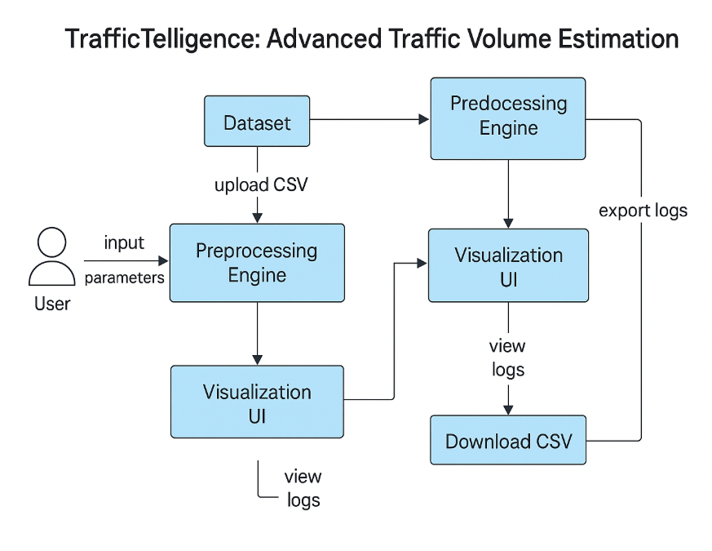

User Stories
Use the below template to list all the user stories for the product.
User Type | Functional Requirement (Epic) | User Story Number | User Story / Task | Acceptance criteria | Priority | Release
Customer (Mobile user) | Traffic Volume Prediction | USN-1 | As a user, I can enter weather and time data to get predicted traffic volume | Predicted volume is shown clearly after input submission | High | Sprint-1
 | UI Interface | USN-2 | As a user, I can view predictions on a simple web interface | Output displayed with date/time and clear formatting | High | Sprint-1
 | Prediction History | USN-3 | As a user, I can view the history of my past predictions | Table or chart of logs shown with previous inputs and outputs | Medium | Sprint-2
City Traffic Analyst | Report Generation | USN-4 | As a traffic analyst, I can download prediction logs for analysis | Log file available for download in CSV/JSON format | Medium | Sprint-3
Admin | Manage Logs | USN-5 | As an admin, I can clear or archive old prediction logs | Logs can be purged or archived with one click | Low | Sprint-4
Developer (Admin) | Model Update | USN-6 | As a developer, I can upload a new trained model to improve prediction accuracy | New model replaces old one and begins serving predictions | Medium | Sprint-4
Developer (Admin) | API Access | USN-7 | As a developer, I can test API endpoints for input/output automation | API returns valid predictions in JSON format | Medium | Sprint-2

